Q.1 Olympics are leading international sporting events featuring summer and winter sports competitions in which thousands of [athletes](https://en.wikipedia.org/wiki/Athletes) from around the world participate in a [variety of competitions](https://en.wikipedia.org/wiki/Multi-sport_event). The Olympic Games are considered the world's foremost sports competition with more than 200 nations participating. The Olympic Games are held every [four years](https://en.wikipedia.org/wiki/Olympiad), with the [Summer](https://en.wikipedia.org/wiki/Summer_Olympic_Games) and [Winter Games](https://en.wikipedia.org/wiki/Winter_Olympic_Games) alternating by occurring every four years but two years apart.

You as an analyst have been given the dataset of Summer Olympics and wants some insights to dig out from dataset:

1. What can be the forecast for India’s for next 2 Olympics

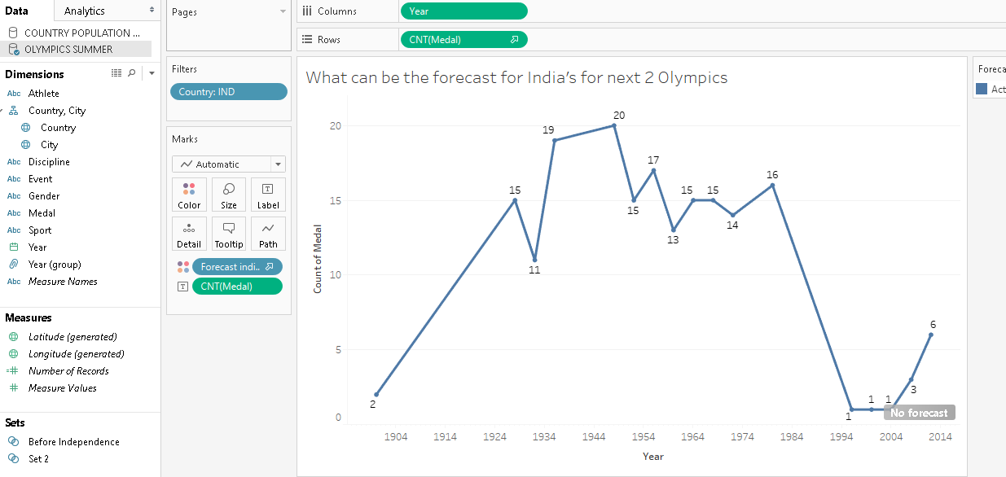

1. According to dataset in which Sport the interest of participants are getting increased?

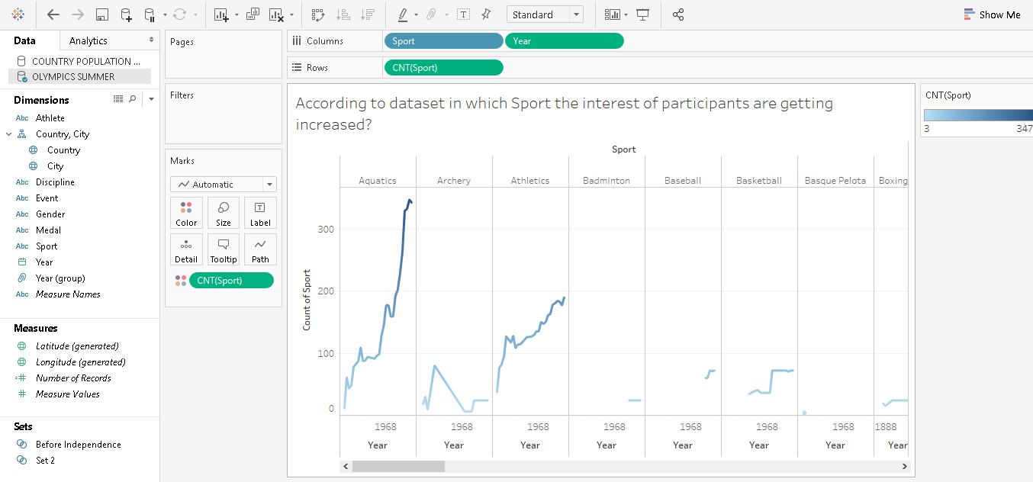

From the trend we can see that the graph is high for Aquatics, Athletics it means participation is increasing.

1. In which Sport, India should invest more for next Olympics?

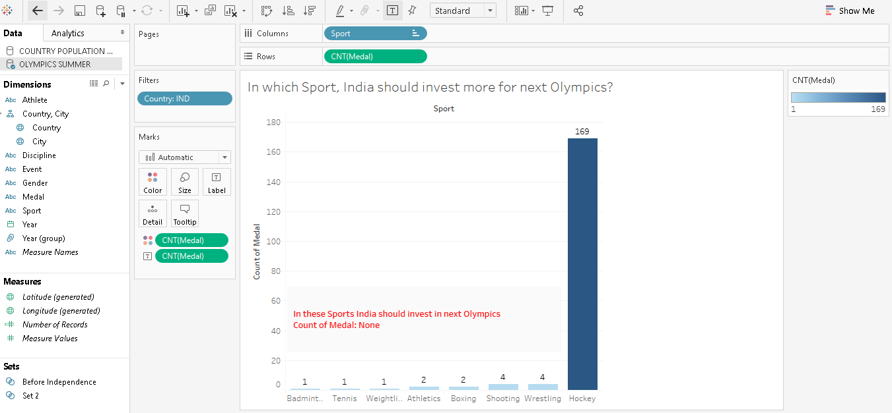

The shown 7 sports need more investment.

1. Do the performance of India in Olympics after Independence rises or not?

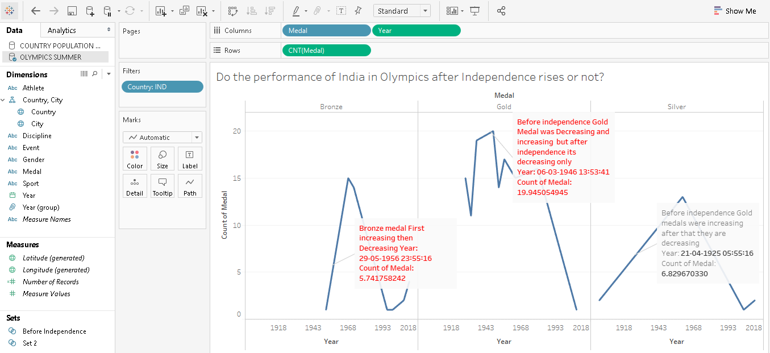

The answer is written in Snap.

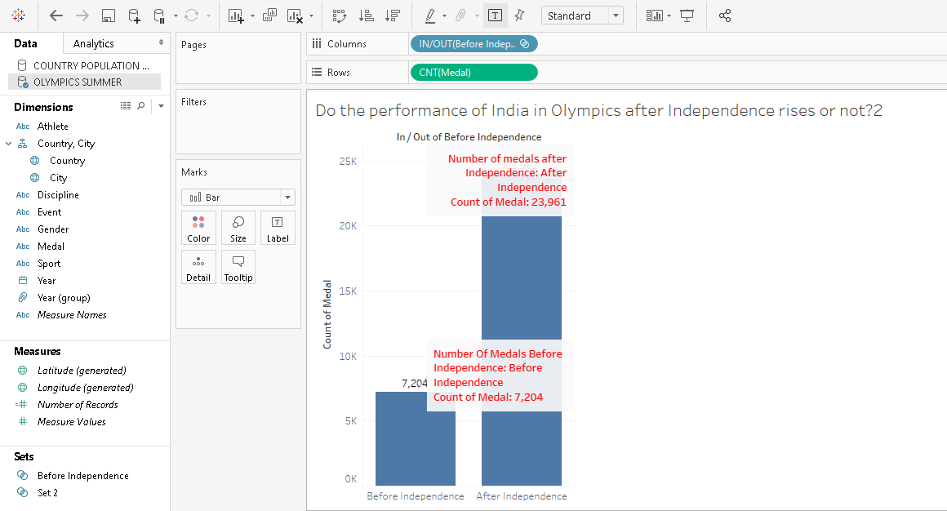

Yes, the performance is higher than before independence.

1. Earlier the participation in Olympics was from MEN but slowly and gradually the other gender has also shown good efforts, analyze whether gender wise interest towards sports are shifting to the MEN games?

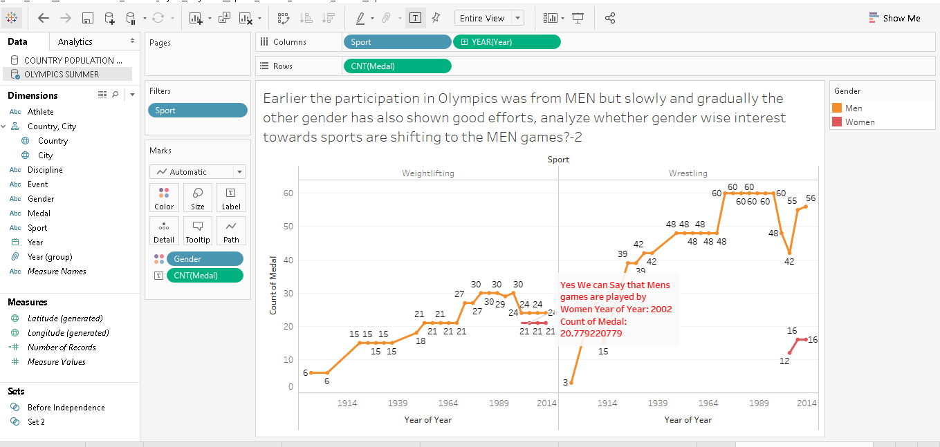

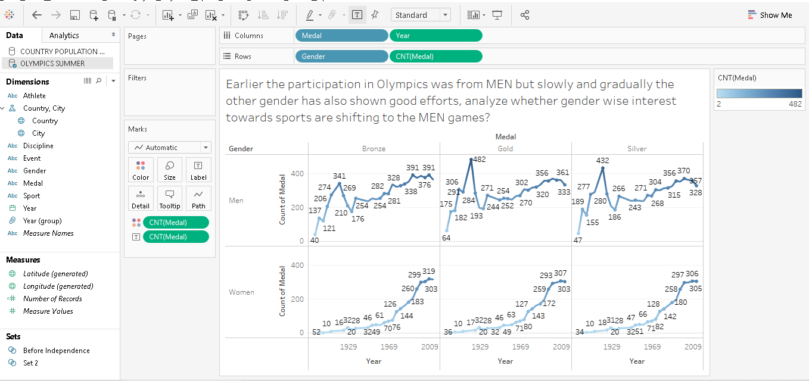

**Q.2** Visualize using Dashboard

1. Using appropriate chart show the sorted Percentage of Medals that India have won till date for each medal type.

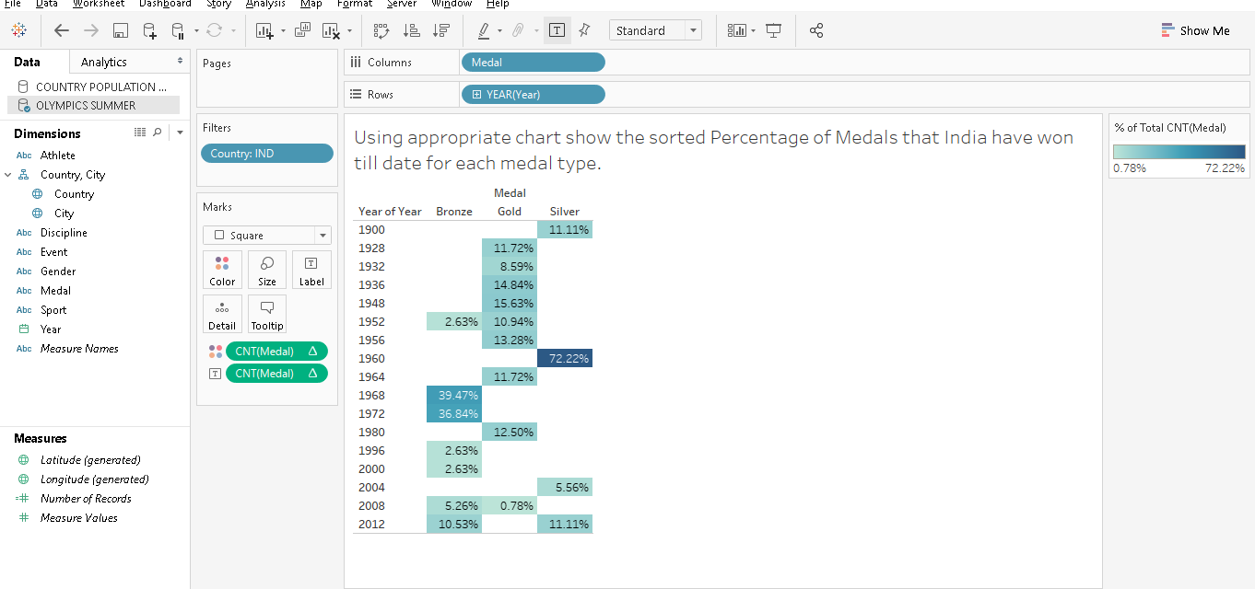

1. Using appropriate chart to show the impact of population and the percentage of medals that each country won.

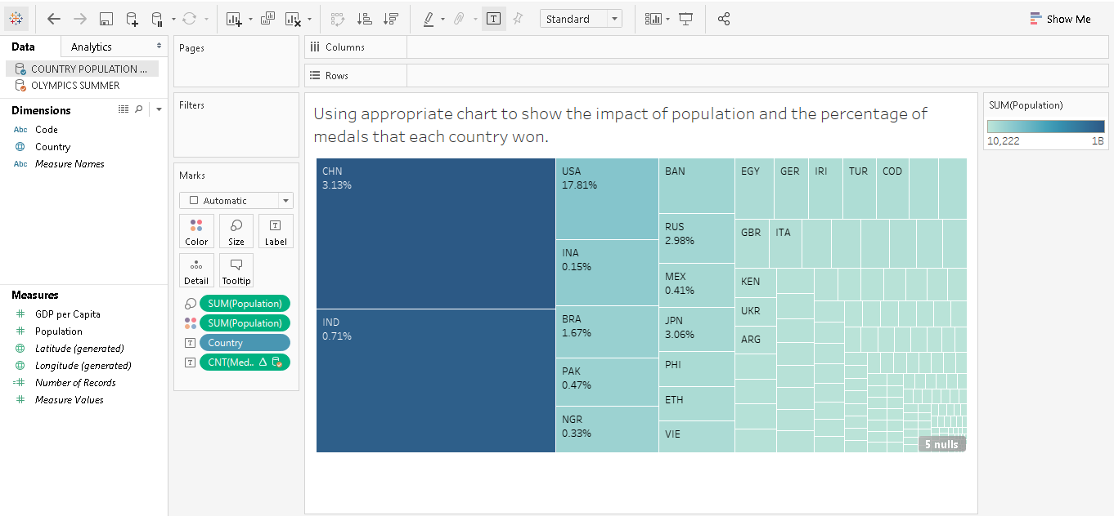

>

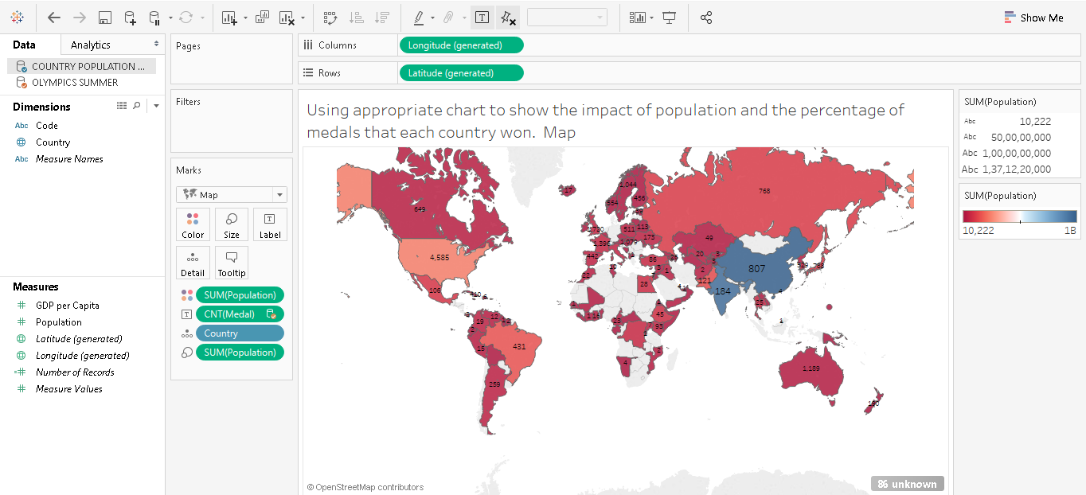

**Dashboard:**

